Pleaseconfirm below hierarchy

Country 🡪Zone 🡪State 🡪City

**For Example**

|  |  |  |  |  |
| --- | --- | --- | --- | --- |
| **Country** | **Zone Name** | **State Name** | **City** | **ZipCode** |
| United States | Zone 0 | NH, ME, VT, MA, RI, CT, NJ | (cities will under each state?) | Please mention all zip code as well |
| United States | Zone 1 | NY, PA DE |  |  |
| United States | Zone 2 | SC, VA, NC, WV, MD, DC |  |  |
| United States | Zone 3 | MS, AL, TN, GA, FL |  |  |
| United States | Zone 4 | MI, IN, OH, KY |  |  |
| United States | Zone 5 | MT, ND, SD, MN, IA, WI |  |  |
| United States | Zone 6 | NE, KS, MO, IL |  |  |
| United States | Zone 7 | TX, OK, AR, LA |  |  |
| United States | Zone 8 | NV, ID, UT, WY, CO, AZ, NM |  |  |
| United States | Zone 9 | CA, OR, WA |  |  |

Pleaseexplain **“BY”** Column in below detail **(Charges Section)**

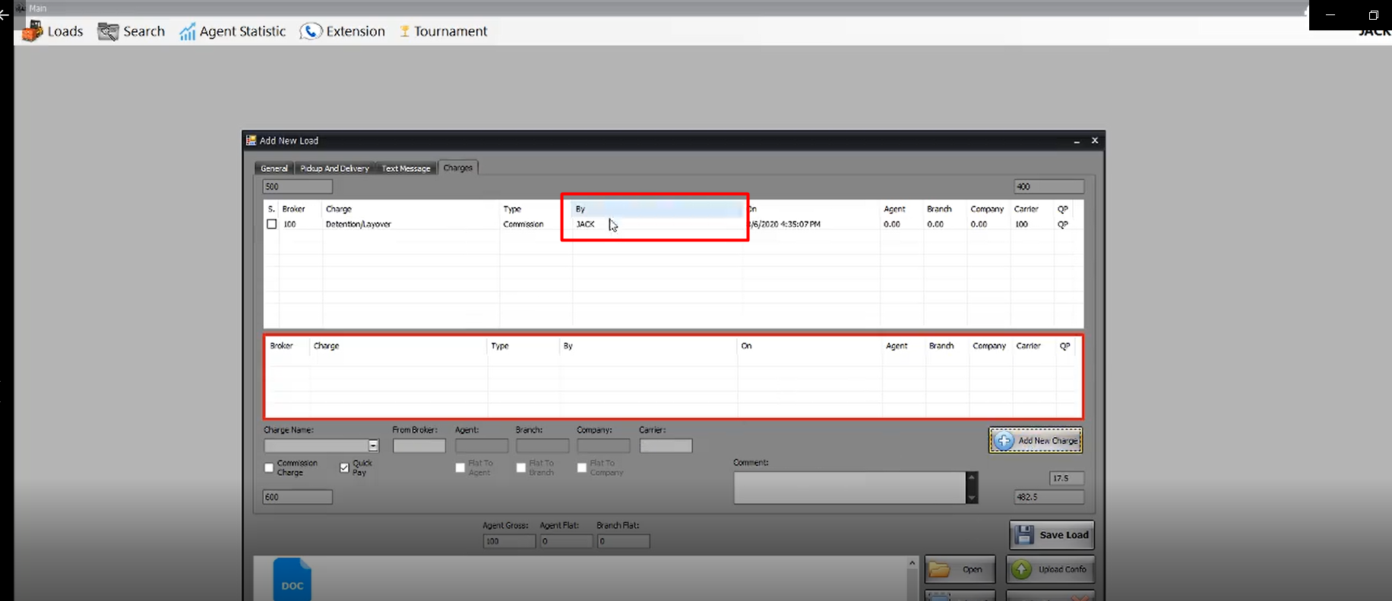

Please explain **“Call” column** in below details (Truck Details)

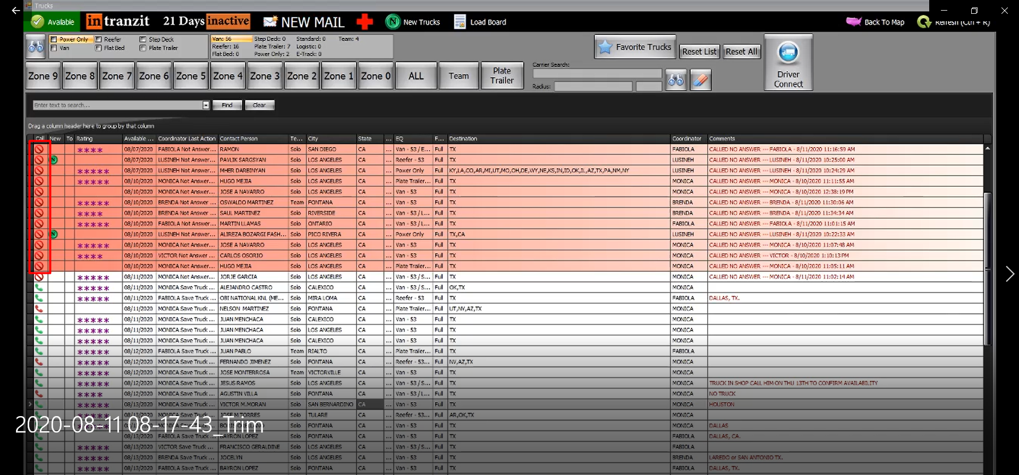

Please explain from where the **Branch** shown in load. What is relation with Load or Broker/Carrier?

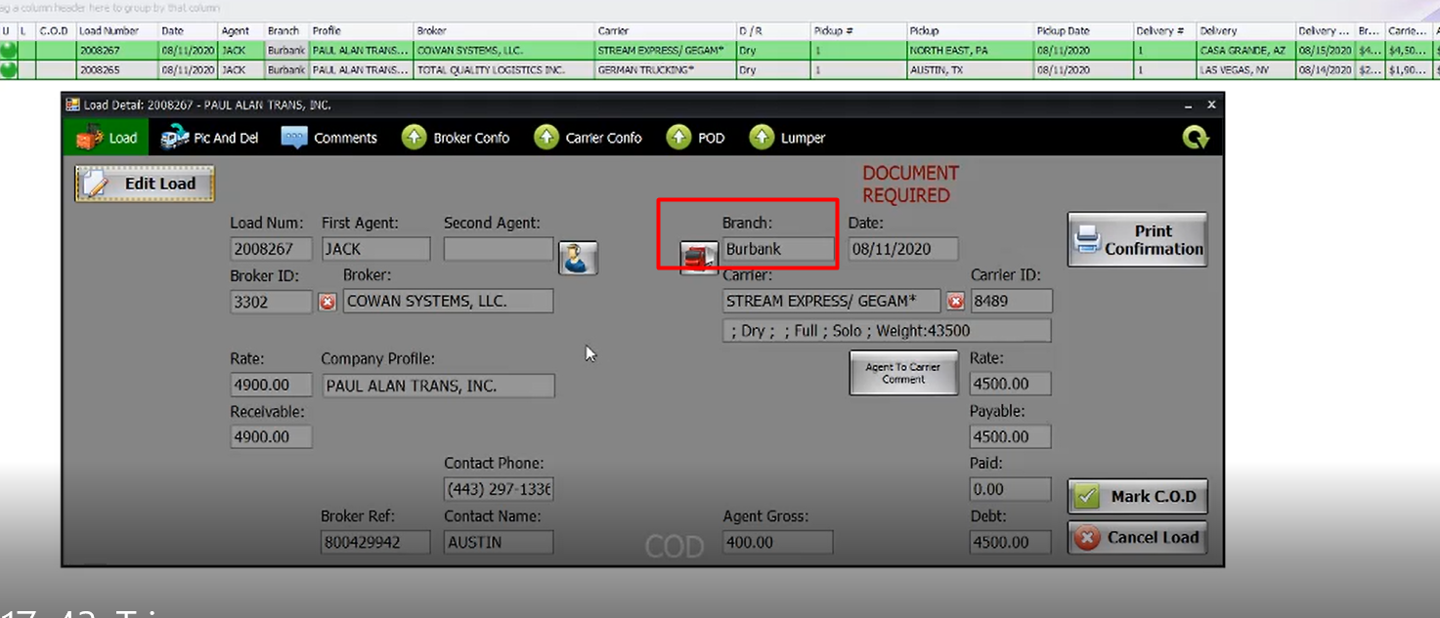

From where the **Dispatcher (name, email, Cellphone)** information is coming for a load Preview? Who is entering? Or to which entity it is linked with?

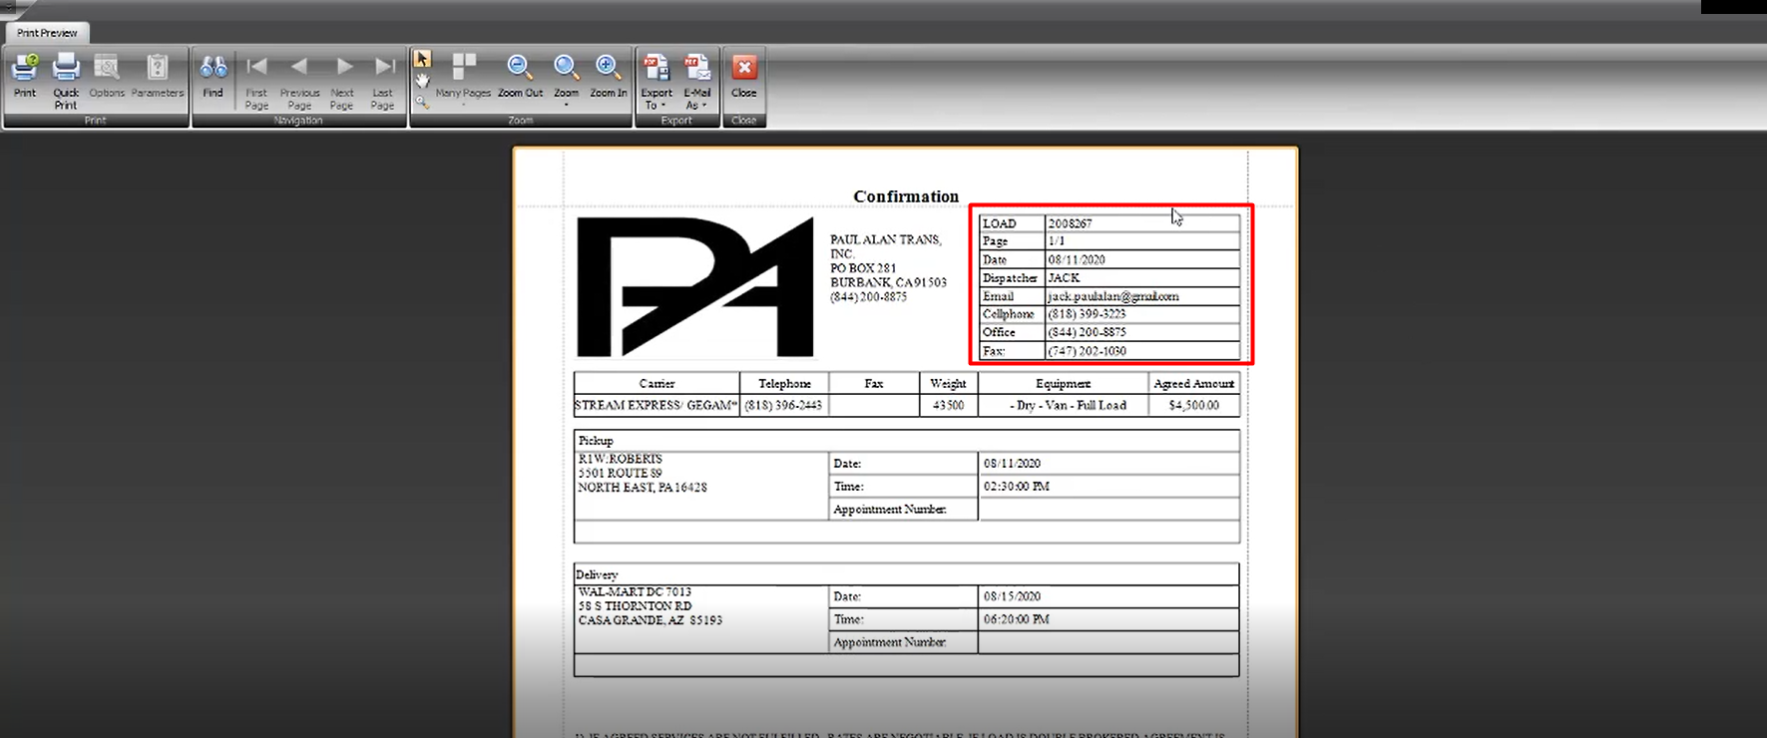

Please explain “**Credit Check”**, which credits are being checked? How these are being available in the balance of the Broker?

Company profile means, if we have multiple companies to select one in which Load job is assigned?

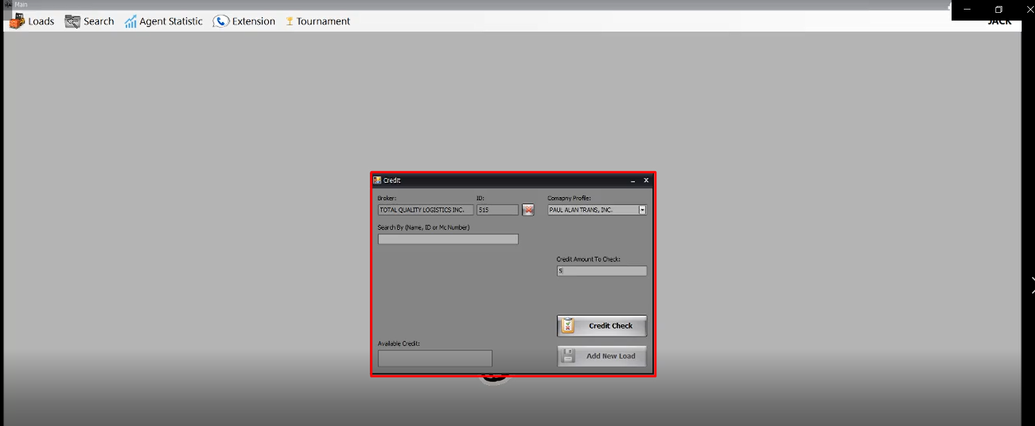

**The basic flow of a Load:**

**Step#1:** You receive a document for a job to be done from customer/tender provider

**Step#2:** Enter Load details in the Load form and attach job document within that. After the load entry, how will the Broker/Carrier will be informed? And after the job has been started, what step we need to do next after adding load in the system?

**Step#3:** Is the below screen **“Broker Confo”** is the third step and then **“Carrier Confo”**? And all of these confirmations are updated by you or Broker or Carrier will have login for the same?

And what is **“Outside Conformation Print”**?

How “Payment Breakdown” works? Please explain it’s business flow as well.

